REPORT OF JUDICIAL COMMITTEE
TO GENERAL SYNOD/TE HĪNOTA WHĀNUI 2022

- The Judicial Committee is established by Title C Canon IV and consists of nine members. There is a requirement for there to be at least two members from each Tikanga and one Bishop, one Ordained Minister and at least three laypersons within the group.
- Bishops, Ordained Ministers, and laypersons enrolled as barristers or solicitors of the High Court of New Zealand and of not less than seven years’ standing or who hold similar qualifications and experience in any of the legal jurisdictions in the Diocese of Polynesia, are eligible for election.
- After election, a Chair and on occasion a Deputy Chair are appointed from amongst the members.
- The primary tasks of the Judicial Committee are set out in Title C Canon IV, section 4, clause 4.1, and involve determination of questions and appeals.
  - The Judicial Committee is also tasked with reviewing motions of General Synod/te Hīnota Whānui and Standing Resolutions on a regular basis after each General Synod, pursuant to the Title C Canon II, clauses 2 and 3.
  - The Judicial Committee does not meet or attend to any business other than when issues are expressly put before it.
- The present membership of the Judicial Committee is:

House of Bishops | The Rt Rev’d Steven Benford
House of Clergy | The Rev’d Joel Rowse
Tikanga Māori | Mr Matanuku Mahuika  Rev’d Pania Houkamau-Ngaheu
Tikanga Pākehā | Judge Chris Harding (Chair)  Judge Anne McAloon  Ms Brigit Brant
Tikanga Pasefika | Mr Walton Morgan  Ms Mele Taliai
General Secretary | The Rev’d Canon Michael Hughes

6. Meetings of the Committee

We have met by email exchange and zoom during the covid period.

The General Synod/te Hīnota Whānui last met, but in a limited fashion in 2020. There were no resolutions passed which were required to be considered for inclusion as a standing resolution and the Committee accordingly did not attend to that task. That decision was made by email circulation.

The committee received an appeal from Mr FaAfuhia Fia against a decision of the Auckland Diocese in relation to the sale of certain land being part of the King’s College school grounds.

It met twice to progress that matter and minutes of the meetings of 19 May and 17 June 2020 are attached. The appeal was subsequently withdrawn, and the Committee met to finalise matters relating to the appeal on 2 July 2020 by email.

The minutes of that meeting are also attached

There was no other business for the Judicial Committee.

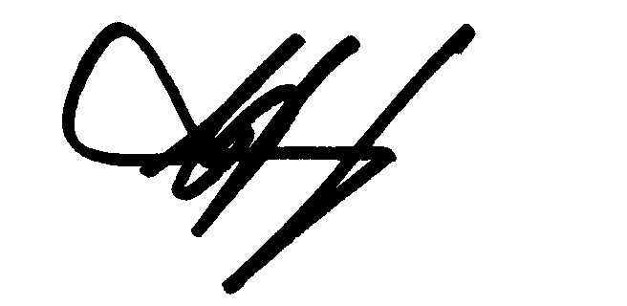
C.J.Harding
Chair of the Committee

